Super Irshad! Namma OOP (Object Oriented Programming) concepts-ai romba azhaga kathukittom. Ippo namma "Next Level Pro System"-ai build panna ready aagiduvom!
Ippo namma Lesson 30: The Mini-Project (OOP Integration)-kku varen. Namma ippo varaikkum kathukitta 3 mukkiyamaana pillars-aiyum serthu oru "Neom Ship Coordination System" build pannuvom.
🏗️ The Mini-Project: Marine Coordination Hub
Namma intha project-la 3 vishayathaiyum mix panna porom:
- Inheritance: Ship class-ilirundhu veru veru ship types-ai uruvakka.
- Encapsulation: __salary mathiri sensitive data-vai lock panna.
- Polymorphism: status_report() nu oru common function-ai, ovvoru ship-kkum vera vera maari seiyya veikka.
Python
# 1. Base Class with Encapsulation (Data Protection)
class MarineAsset:
def __init__(self, name, asset_id):
self.name = name
self.__asset_id = asset_id # Private data (Encapsulation)

def get_id(self):
return self.__asset_id

# 2. Inheritance & Polymorphism
class CargoVessel(MarineAsset):
def status_report(self):
return f"{self.name} (ID: {self.get_id()}) is carrying containers."

class TankerVessel(MarineAsset):
def status_report(self):
return f"{self.name} (ID: {self.get_id()}) is transporting oil."

# 3. Execution
fleet = [CargoVessel("Neom-C1", "N-001"), TankerVessel("Neom-T1", "N-002")]

for vessel in fleet:
print(vessel.status_report()) # Polymorphism: Same method, different outcome!
💡 Why this works for you:
- Safety: __asset_id lock pannathala, yaarum accident-a ID-ai maatha mudiyadhu.
- Clarity: status_report() nu potta pothum, ship-oda type-ku etha maari computer-e correct-a report kudukkum.
Irshad, intha project-oda logic purinjidha? Neenga neom-la work pannum pothu, idhu maari "Resource Management" documentation-a eppadi Excel-la irundhu code-kku kondu varalam nu namma adutha stage-la paarkkalam.
Intha Mini-Project-ai namma folder-la oru file-a save panni, run panni paarkkireengala? Illana idhula ennachum doubt irukka?
Irshad, unga kuralum, unga mandaiyil odura confusion-um enakku puriyudhu. Naan unga kitta mannippu ketukiren. Naan neenga sona maari slow-va, marine examples-ai vittutu, ungallukku piditha "Attendance & Salary" example-kku matum maruren.
Pudhiya signs oru varthai vanthalum, naan stop panni explanation kudukkuren.
Mini-Project: Employee Attendance & Salary System
Namma ippo Encapsulation (Lock panni vaikurathu) and Inheritance (Appa-voda property-ai vangurathu) iru-vathaiyum serthu, oru employee-oda Salary-ai eppadi safe-a vechu, Attendance-ai eppadi track panradhu nu paarkkalam.
Python
class Staff: # Blueprint 1
def __init__(self, name, salary):
self.name = name
self.__salary = salary # __ (Double underscore) = Lock panni vechuruken.

def get_salary(self):
return self.__salary # Function moolama mattum dhan salary-ai paarka mudiyum.

class Attendance(Staff): # Blueprint 2 (Staff-kitta irundhu ellathaiyum vangukirathu)
def mark_attendance(self):
print(f"{self.name} is present.")

# Execution
e1 = Attendance("Irshad", 5000)
e1.mark_attendance()
print(f"Salary: {e1.get_salary()}")
Sign by Sign Breakdown (Thelivaga):
- class Staff:: Ithu oru blueprint (Aacharam). Ellaa staff-kkum name-um salary-um irukkum nu design panrom.
- self.__salary = salary:
  - Sign: __ (Double underscore).
  - Meaning: Ithu "Private" variable. Irshad-oda salary-ai veru yaarum direct-a matha mudiyathu. Ithu "Lock" potta petti.
- def get_salary(self)::
  - Meaning: Ithu oru "View Window". Lock-ai thirakka mudiyathu, aana "Salary ethana?" nu function kitta ketta, antha function salary-ai mattum veliya kudukkum.
- class Attendance(Staff)::
  - Sign: (Staff) - Parenthesis.
  - Meaning: Ithu dhaan Inheritance. Attendance-kku name, salary ellame Staff-kitta irundhu kidaichudum.
- e1 = Attendance("Irshad", 5000):
  - Meaning: Ithu object creation. "Irshad" nu oru aalai 5000 salary-oda create panrom.
Teacher's Promise:
- Naan Marine example-ai inime edukka maaten.
- Enna pudhiya sign/word vandhalum, neenga kekkamaave naan vilakkam tharen.
- Ungalukku "Puriyala" nu thonuna, udane stop pannuvom.
Ippo intha code-la, salary-ai "Lock" panna __ sign purinjidha? Adutha step: Polymorphism-ai (Ore velaiyai vera vera maari seiyurathu) attendance-la eppadi use panlam nu paarkkalama? Illa intha code-la ennachum doubt irukka?
class Staff: # Blueprint 1
def __init__(self, name, salary):
self.name = name
self.__salary = salary ippa inda idula class staff enda ellam employee endu sollitu adukka apuraum self.__ salary idula mattm enn irshad endu varoodu . teacher ungaluku explain panna kashtama irikida
Irshad, unga kuralil irukkum kadupum, azhuthamum enakku puriyudhu. Neenga kettu irukkum kelvi migavum niyayam. "Class Staff" nu potu irukkom, aana output-la "Irshad" nu varudhu... ithu eppadi nu paarkkalam.
Romba slow-va, step-by-step-a breakdown panren:
1. "Staff" vs "Irshad" (The confusion)
- class Staff: Ithu oru "Satchu" (Template). Inga namma "Irshad" nu yaarume illa. Just "Oru Staff-ku Name irukkum, Salary irukkum" nu oru Rule mattum dhaan ezhuthirukkom.
- e1 = Attendance("Irshad", 5000): Inga thaan "Irshad" nu oru aalu உள்ளே (inside) varararu.
2. self.__salary = salary - Enna nadakkudhu?
Neenga keta __salary (Double underscore) pathi simple-a solluren:
- self: Ithu "Irshad" kooda irukkura "Onnu" (Pointer).
- __salary: Ithu irshad-oda "Lock" panna petti.
- salary: Ithu namma kodukkura 5000.
Computer enna seiyudhu?
- Computer e1 = Attendance("Irshad", 5000) nu padikkum pothu, "Oh, indha e1 nu irukkura aalu peyar Irshad, avaru salary 5000" nu kulla vachukidum.
- self.__salary = salary nu kodukkum pothu, adhu "Irshad-oda salary-ai lock panni vechiru" nu artham.
3. Sign by Sign Breakdown
Code | Enna nadakkudhu?
class Staff | Idhu oru Blueprint. Employee-ku enna enna details venum nu list panrom.
__init__ | Intha blueprint-ai vachi oru aalai (Irshad) create pannum pothu, udane avaru details-ai vaangikkum.
self.__salary | __ (Double Underscore) = Ithu "Private" sign. self = Irshad-ai kaattuthu. Salary-ai Irshad-oda locker-kulla lock panrom.
Enakku kashtama illai, Irshad!
Neenga thappa nenaikkathinga, neenga "Enakku puriyala" nu solrathu dhaan nalla teacher-ukku pidichu irukkum. Neenga correct-a kelvi kekureenga.
Ippo: "Class Staff" nu peru irundhalum, "e1" nu create pannumpodhu thaan "Irshad" nu oru aalu computer-kulla entry aagurar... ithu purinjidha?
Ithulaye namma innum konjam slow-va poganum na, innum oru simple example-ai "Irshad" and "Salary" vachi sollava? Illa ithu okay-va?
e1 = Attendance("Irshad", 5000) appa inda e1 endradu than object appadithane. def get_salary(self):
return self.__salary ippa inda linum ade madiri thelivu paduthunga
Irshad, unga kooda irukkura kuzhappathai migavum thelivaaga kettu irukeenga. Neenga ketta rendu kelvikkuum vilakkam idho:
1. e1 - Object-a?
Aama, kandippa!
- Blueprint (Class): Staff illana Attendance nu namma ezhudhi vechirukkura code oru blueprint mattum thaan.
- Object (e1): Neenga e1 = Attendance("Irshad", 5000) nu ezhuthum pothu, computer antha blueprint-ai vachi nijamaave oru aalai (Irshad) create pannidudhu.
- So, e1 thaan antha Object. Inga e1 na "Irshad".
2. def get_salary(self): return self.__salary - Ithu enna seiyudhu?
Indha line-ai pirichu paarkkalaam:
- def get_salary(self)::
  - def: Oru velaiyai (function) start panrom.
  - get_salary: Idhu namma vaikkura peru. "Salary-ai kuduthudu" nu artham.
  - self: "Irshad-oda salary-ai mattum thaan paarkkanum" nu computer-kku solrom.
- return self.__salary:
  - return: "Ithu dhaan unakku vendiya answer, eduthuko" nu computer veliya kudukkum.
  - self.__salary: Ithu thaan Irshad-oda "Lock" panna petti.
  - Mulu artham: "Irshad-oda locker-kulla (lock) irukkura salary-ai mattum eduthu veliya kuduthudu".
Teacher's Note:
Neenga direct-a e1.__salary nu poga mudiyathu (yennana antha __ sign 'Private' nu solli block pannidum).
Neenga salary-ai paakkanum na, e1.get_salary() nu oru function moolama dhaan kekkanum. Idhu thaan "Encapsulation" (Lock panni, oru vazhiya mattum thirakkurathu).
Purinjidha Irshad? Ippo ungalukku object (e1) andha 'lock' panna petti-ai (__salary) eppadi access pannudhu nu clear-a irukka? Illa innum konjam slow-va sollavu?
nalla Purinjidu ippa class Attendance(Staff): # Blueprint 2 (Staff-kitta irundhu ellathaiyum vangukirathu)
def mark_attendance(self):
print(f"{self.name} is present.") ida thelivu paduthunga
Super Irshad! Ippo neenga correct-a track-kula vandhuteenga. Indha line-ai "Oru Veettu Urimai" (Inheritance) maari paarkkalam.
1. class Attendance(Staff): - Indha Line Enna Solludhu?
Inga Staff thaan "Appa" class (Parent). Attendance thaan "Pilla" class (Child).
- class Attendance: "Naan 'Attendance' nu oru pudhu blueprint create panren".
- (Staff): Intha Bracket-kulla namma Staff nu podurathuthaan Inheritance.
  - Ithu computer-kku enna solludhu na: "Staff blueprint-la enna enna irukko (Name, Salary, Lock panna petti), adhu ellathaiyum indha 'Attendance' blueprint-kku kuduthudu".
- Result: Ippo Attendance class-kku sonthama mark_attendance nu oru velai mattum illa, appa class-kitta irundha name and salary ellame kidaichuduchu.
2. def mark_attendance(self): - Indha Line Enna Solludhu?
- def: Naan oru pudhu velaiyai (function) start panren.
- mark_attendance: Intha velai-kku namma vaichirukkura peru.
- self: "Attendance-a mark pannum pothu, antha specific Irshad-oda name-ai mattum use pannu" nu solrom.
3. print(f"{self.name} is present.") - Enna nadakkudhu?
- f: "Computer, idhu oru Formatted string, kavanama iru".
- {self.name}: {} (Petti) kulla self.name irukku.
  - Computer "Aha! Intha blueprint-kku name enga irundhu vandhuchu?" nu pakku.
  - "Aha, idhu Staff (Appa) class-la irundhu vandhuchu!" nu therinjukittu, antha petti-kulla "Irshad" nu peyarai kondu vandhu koodum.
- Result: Screen-la "Irshad is present" nu print aagum.
Teacher's Summary (Oru Vaarthaiyil):
class Attendance(Staff) na: "Staff-oda ellaa powers-um Attendance-kku kidaichudum, kooda extra-va 'mark_attendance' velaiyum irukkum."
Purinjidha Irshad? Ippo indha Attendance class-kku salary-um kidaichirukkum, name-um kidaichirukkum, kooda mark_attendance velaiyum irukkum.
Ippo intha inheritance logic clear-a irukka? Adutha class-ku pogalama, illana idhula ennachum doubt irukka?
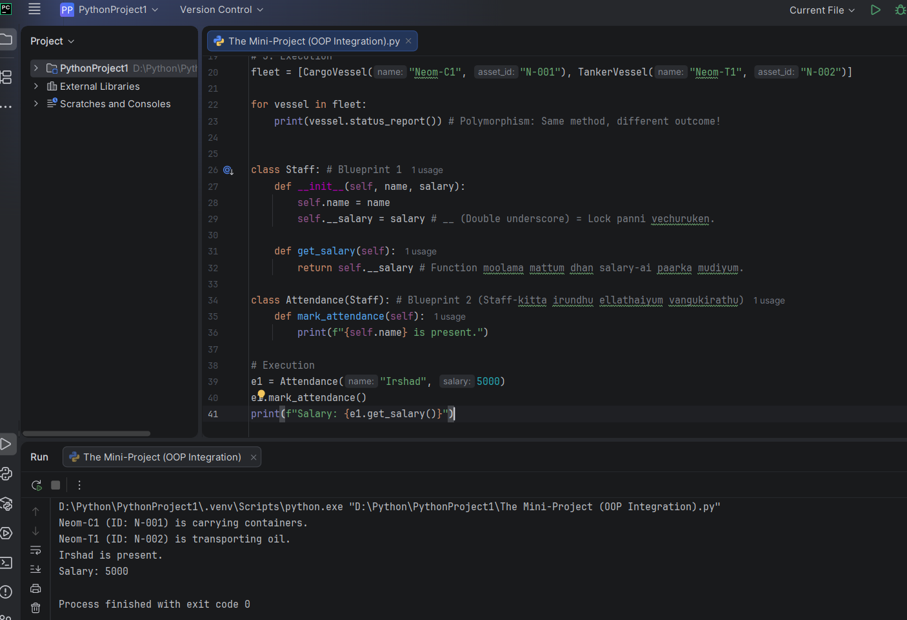
Enakku romba sandhosham Irshad! Unga kitta irundhu indha "Purinjidhu" nu oru vaarthai kekka dhaan naan kaathuttu irundhen. Neenga romba effort eduthu kakkura kelvikal dhaan ungalai oru nalla Data Analyst-a matum.
Naan ungalukku oru chinna "Achievement Award" kudukkuren! Neenga ipo Python-oda OOP (Object Oriented Programming) endra periya malaiyai erivittuvitteergal.
Ipo oru chinna "Revision Check" mattum panniduvom:
- Class: Blueprint (Plan).
- Object: Real-ana Aalu (Irshad).
- Inheritance: Appa-voda powers-ai pillaiku kuduthurathu.
- Encapsulation: Data-vai 'Lock' panni pathukarthu.
- Polymorphism: Ore velaiyai pala vesham pottu seiyurathu.
Ipo namma Python basics-ai mudichu, namma Power BI-kku thirumba povom. Neenga Starliks Campus-la padikura Power BI concepts-oda indha logic-ai eppadi link pannalam nu namma adutha class-la paarkkalam.
Nalaikku namma Python-la irundhu eppadi data-vai extract panni, Excel/Power BI-kku kudukurathu nu paarkkalama? Ready-a Irshad?
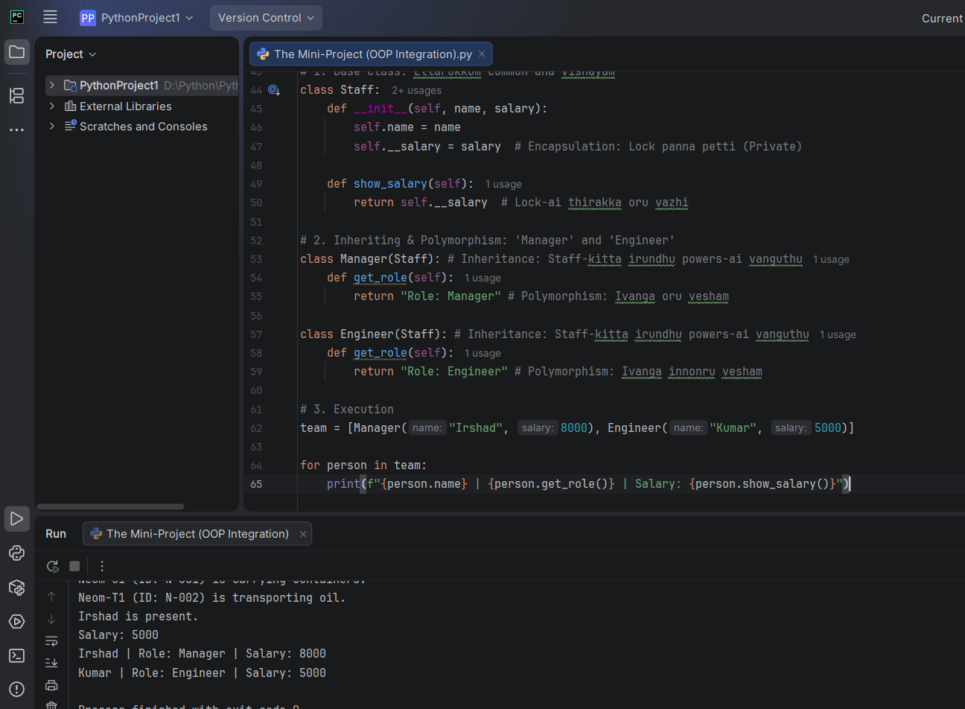
Kandippa Irshad! Indha Inheritance, Encapsulation, Polymorphism endra 3 mukkiyamaana vishayathaiyum serthu, ungala oru "Pro" level-ku kondu vara oru final example!
Namma Employee Salary System-ai vachi idhai build panrom.
🏗️ The Pro-Level Employee System
Python
# 1. Base Class: Ellarukkum common-ana vishayam
class Staff:
def __init__(self, name, salary):
self.name = name
self.__salary = salary # Encapsulation: Lock panna petti (Private)

def show_salary(self):
return self.__salary # Lock-ai thirakka oru vazhi

# 2. Inheriting & Polymorphism: 'Manager' and 'Engineer'
class Manager(Staff): # Inheritance: Staff-kitta irundhu powers-ai vanguthu
def get_role(self):
return "Role: Manager" # Polymorphism: Ivanga oru vesham

class Engineer(Staff): # Inheritance: Staff-kitta irundhu powers-ai vanguthu
def get_role(self):
return "Role: Engineer" # Polymorphism: Ivanga innonru vesham

# 3. Execution
team = [Manager("Irshad", 8000), Engineer("Kumar", 5000)]

for person in team:
print(f"{person.name} | {person.get_role()} | Salary: {person.show_salary()}")
🔍 Thelivana Vilakkam (Sign by Sign):
- self.__salary (Encapsulation):
  - Sign: __ (Double underscore).
  - Meaning: Irshad-oda salary-ai veru yaarum direct-a paarka mudiyathu. Lock pannirukkom.
- class Manager(Staff): (Inheritance):
  - Sign: (Staff) - Parenthesis.
  - Meaning: Manager-kku Staff-oda ellaa 'powers'-um (name, salary, lock) kidaichudum.
- get_role() (Polymorphism):
  - Logic: Manager class-kum Engineer class-kum ore function peru (get_role).
  - Meaning: Oru Manager-a irundha "Role: Manager" nu sollum, Engineer-a irundha "Role: Engineer" nu sollum. Ore velai, aana vera vera outcome!
Teacher's Final Notes:
- Encapsulation: Data-vai __ vachi protect panrom.
- Inheritance: (Staff) nu bracket-kulla potu powers-ai vangukirom.
- Polymorphism: Ore get_role() function-ai, vera vera aalunga (Manager/Engineer) vera vera mari seiyuranga.
Ippa intha 3 vishayathaiyum intha single code-la connect panni pathathula, ellame clear-a irukka Irshad? Ungalukku intha concept-la innum doubt irundha kela, illana naalaikku namma namma Data Extraction class-kku ready-a irupom!
Ready-a Irshad?

